**LAS Activity 210**

Hyponyms (PORTFOLIO)

**This portfolio activity is 0.1 from your total portfolio points (2.0).**

**Instructions**

Observe the following chart and make a similar one of your own in the chart on the following page.

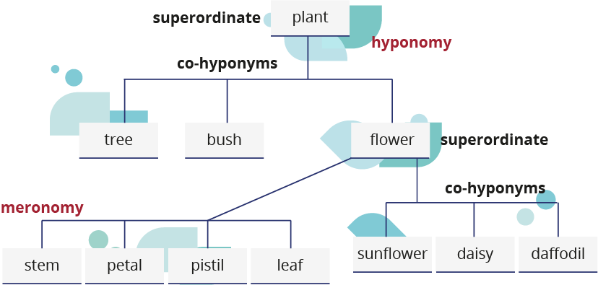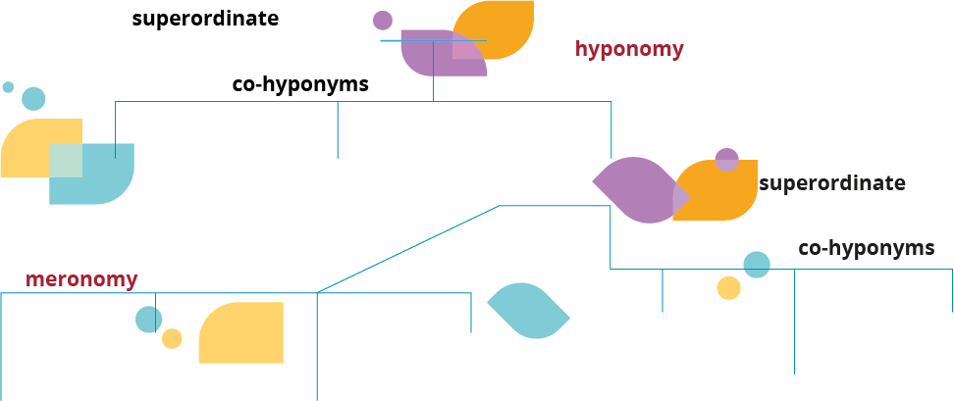

Write here...

Write here...

Write here...

Write here...

Write here...

Write here...

Write here...

Write here...

Write here...

Write here...

Write here...